Introduction
6 min
Data lies at the heart of nearly every problem in the business world and society. Having the right tools to manipulate data and organize it in a meaningful way is integral to performing data analyses and discovering unique insights!
The dplyr package in R is designed to make data manipulation tasks simpler and more intuitive than working with base R
functions
Preview: Docs Loading link description
only. Called a “grammar of data manipulation,” dplyr provides functions that solve many challenges that arise when organizing tabular data (i.e., data in a table with rows and columns). Tabular data has a lot of the same functionality as tables from SQL or Excel, but dplyr adds the power of R.

In addition to learning how to load data into R with the readr package, this lesson will introduce how to perform the following data manipulation tasks with dplyr:
- select columns of a table
- filter rows of a table
- arrange rows of a table in order
dplyr and readr are a part of the tidyverse, a collection of R packages designed for data science. In this and future lessons, you will use different packages of the tidyverse to more easily analyze and visualize data!
The tidyverse is a package itself, and it can be imported at the top of your file if you need to use any of the packages it contains.
In our lessons, however, we will explicitly import the packages within the tidyverse that we are using. To get started with readr and dplyr, you can import them at the top of your .Rmd R-markdown file or .R script:
library(readr)library(dplyr)Copy to Clipboard
Instructions
- Checkpoint 1 PassedThe notebook.Rmd file in the code editor contains the code to load, inspect and manipulate a data frame containing data from the top 7 most popular music groups of 2018.Load the readr and dplyr libraries in the code block at the top of the notebook so the code can properly run.By the end of this lesson, you will be able to perform this same analysis!
---title: "Introduction to Data Frames"output: html_notebook---```{r message=FALSE, warning=FALSE}# load librarieslibrary(readr)library(dplyr)

```

```{r}
# load data frame
artists <- read_csv('artists.csv')
```

```{r}
# inspect data frame
artists
head(artists)
summary(artists)
```

```{r}
# select columns, filter and arrange rows of artists
artists_manipulated <- artists %>%
select(-country,-year_founded,-albums) %>%
filter(spotify_monthly_listeners > 20000000, genre != 'Hip Hop') %>%
arrange(desc(youtube_subscribers))
artists_manipulated
```

What is a Data Frame?
5 min
A data frame is an R object that stores tabular data in a table structure made up of rows and columns. You can think of a data frame as a spreadsheet or as a SQL table. While data frames can be created in R, they are usually imported with data from a CSV, an Excel spreadsheet, or a SQL query.
Data frames have rows and columns. Each column has a name and stores the values of one variable. Each row contains a set of values, one from each column. The data stored in a data frame can be of many different types: numeric, character, logical, or NA.
A data frame containing the address, age and name of students in a class could look like this:
address | age | name
123 Main St. | 34 | John Smith
456 Maple Ave. | 28 | Jane Doe
789 Broadway | 51 | Joe Schmo

As seen in the first row, the column names of this data frame are address, age, and name.
Note: when working with dplyr, you might see functions that take a data frame as an argument and output something called a tibble. Tibbles are modern versions of data frames in R, and they operate in essentially the same way. The terms tibble and data frame are often used interchangeably. Here on Codecademy we will use the term data frame!
Instructions
- Checkpoint 1 PassedThe code in notebook.Rmd loads a data frame named songs that contains data about 7 songs from popular music groups (you’ll learn how to load a data frame yourself shortly).Type songs in the empty code block and run the code to view the data frame. Make sure to click the arrow to explore each column!
---title: "Introduction to Data Frames in R"output: html_notebook---```{r message=FALSE, warning=FALSE}# load librarieslibrary(readr)library(dplyr)``````{r}# load data framesongs <- read_csv('songs.csv')``````{r}songs```

CSVs
6 min
When working with data frames, most of the time you will load in data from an existing data set. One of the most common formats for big datasets is the CSV.
CSV (comma separated values) is a text-only spreadsheet format. You can find CSVs in lots of places such as:
- online datasets from governments and companies (here’s an example from data.gov)
- exported from Excel or Google Sheets
- exported from SQL
The first row of a CSV contains column headings. All subsequent rows contain values. Each column heading and each variable is separated by a comma:
column1,column2,column3value1,value2,value3value4,value5,value6Copy to Clipboard
That example CSV represents the following table:
column1 | column2 | column3
value1 | value2 | value3
value4 | value5 | value6
Instructions
- Checkpoint 1 Passed1.You run a cupcake store and want to create a record of all of the cupcakes that you offer.Write the following data as a CSV in cupcakes.csv:Scroll all the way to the right in the table to see each column. And make sure your spelling is correct!

Loading and Saving CSVs
6 min
When you have data in a CSV, you can load it into a data frame in R using readr‘s read_csv() function:
df <- read_csv('my_csv_file.csv')Copy to Clipboard
- In the example above, the read_csv() function is called
- The CSV file my_csv_file.csv is passed in as an argument
- A data frame containing the data from my_csv_file.csv is returned
You can also save data from a data frame to a CSV using readr‘s write_csv() function:
write_csv(df,'new_csv_file.csv')Copy to Clipboard
In the example above, write_csv() takes two arguments:
- df, which represents a data frame object
- new_csv_file.csv, the name of the CSV file that will hold the data from the data frame
By default, this method will save the CSV file to your current directory.
Instructions
- Checkpoint 1 Passed1.artists.csv contains data from the top 7 most popular music groups of 2018. Within the empty code block, load the CSV into a data frame artists. On the line below, type artists and run the code to view the rendered data frame.Use the arrows to view the different columns of the data frame!
---title: "Introduction to Data Frames in R"output: html_notebook---```{r message=FALSE, warning=FALSE}# load librarieslibrary(readr)library(dplyr)``````{r}# load data frameartists <- read_csv('artists.csv')artists```

Inspecting Data Frames
4 min
When you load a new data frame from a CSV, you want to get an understanding of what the data looks like.
If the data frame is small, you can display it by typing its name df. If the data frame is larger, it can be helpful to inspect a few rows of the data frame without having to look at the rest of it.
The head() function returns the first 6 rows of a data frame. If you want to see more rows, you can pass an additional argument n to head(). For example, head(df,8) will show the first 8 rows.
The function summary() will return summary statistics such as mean, median, minimum and maximum for each numeric column while providing class and length information for non-numeric columns.
Instructions
- Checkpoint 1 PassedView the entire data frame by typing artists in the empty code block and running the code.
- Checkpoint 2 PassedWithin the same code block, inspect artists using head(). How many rows are returned?
- Checkpoint 3 PassedStill within the same code block, call summary() on artists and run the code to view the summary statistics of the data frame.
---title: "Introduction to Data Frames in R"output: html_notebook---```{r message=FALSE, warning=FALSE}# load librarieslibrary(readr)library(dplyr)``````{r message=FALSE}# load data frameartists <- read_csv('artists.csv')``````{r}# inspect data frameartistshead(artists)summary(artists)```

Piping
4 min
One of the most appealing aspects of dplyr is the ability to easily manipulate
data frames
Preview: Docs Data frames are objects that store data into two dimensions of columns and rows.
. Each of the dplyr
functions
Preview: Docs Functions are blocks of code that perform specific tasks and can be repeatedly called within other parts of the code.
you will explore takes a data frame as its first argument.

The pipe operator, or %>%, helps increase the readability of data frame code by piping the value on its left into the first argument of the function that follows it. For example:
df %>% head()Copy to Clipboard
pipes the data frame df into the first argument of head(), becoming
head(df)Copy to Clipboard
The true power of pipes comes from the ability to link multiple function calls together. Once you learn some of dplyr’s functions, we’ll revisit pipes and see how they are so useful!
Note: the pipe operator is not a part of base R. It comes from the magrittr package, but do not worry about loading magrittr in your code. Any time you load a package from the tidyverse, like dplyr, %>% will automatically be loaded!
Instructions
- Checkpoint 1 PassedUse a pipe %>% to inspect artists with head().

---title: "Introduction to Data Frames in R"output: html_notebook---```{r message=FALSE, warning=FALSE}# load librarieslibrary(readr)library(dplyr)``````{r message=FALSE}# load data frameartists <- read_csv('artists.csv')``````{r}# inspect data frame with pipeartists %>% head()```

Selecting Columns
9 min
Suppose you have a data frame called customers, which contains the ages of your business’s customers:
name | age | gender
Rebecca Erikson | 35 | F
Thomas Roberson | 28 | M
Diane Ochoa | 42 | NA

For your analysis, you only care about the age and gender of your customers, not their names. The data frame you want looks like this:
age | gender
35 | F
28 | M
42 | NA

You can select the appropriate columns for your analysis using dplyr‘s select() function:
select(customers,age,gender)Copy to Clipboard
- select() takes a data frame as its first argument
- all additional arguments are the desired columns to select
- select() returns a new data frame containing only the desired columns
But what about the pipe %>%, you ask? Great question. You can simplify the readability of your code by using the pipe:
customers %>% select(age,gender)Copy to Clipboard
When using the pipe, you can read the code as: from the customers table, select() the age and gender columns. From now on we will use the pipe symbol where appropriate to simplify our code.
Instructions
- Checkpoint 1 Passed1.Select the group column of artists using select() and save the result to artist_groups. View artist_groups.
- Checkpoint 2 Passed2.Select the group, spotify_monthly_listeners, and year_founded columns of artists using select() and save the result to group_info. View group_info.

---title: "Introduction to Data Frames in R"output: html_notebook---```{r message=FALSE, warning=FALSE}# load librarieslibrary(readr)library(dplyr)``````{r message=FALSE}# load data frameartists <- read_csv('artists.csv')``````{r}# select one columnartist_groups <- artists %>% select(group)artist_groups``````{r}# select multiple columnsgroup_info <- artists %>% select(group,spotify_monthly_listeners,year_founded)group_info```

Excluding Columns
6 min
Sometimes rather than specify what columns you want to select from a data frame, it’s easier to state what columns you do not want to select. dplyr‘s select() function also enables you to do just that! Consider a customers data frame that contains biographical information for the customers of your business:
name | address | phone | age
Martha Jones | 123 Main St. | 234-567-8910 | 28
Rose Tyler | 456 Maple Ave. | 212-867-5309 | 22
Donna Noble | 789 Broadway | 949-123-4567 | 35
Amy Pond | 98 West End Ave. | 646-555-1234 | 29
Clara Oswald | 54 Columbus Ave. | 714-225-1957 | 31

You are interested in analyzing where your customers live and how old they are. For your analysis, you do not care about the name and phone associated with a customer, only their address and age. To exclude the columns you do not need:
customers %>% select(-name,-phone)Copy to Clipboard
- the data frame customers is piped into select()
- the columns to remove, prepended with a -, are given as arguments
- a new data frame without the name and phone columns is returned
Instructions
- Checkpoint 1 Passed1.Select all columns of artists except albums using select() and save the result to no_albums. View no_albums.
- Checkpoint 2 Passed2.Select all columns of artists except genre, spotify_monthly_listeners, and year_founded using select() and save the result to df_cols_removed. View df_cols_removed.
---title: "Introduction to Data Frames in R"output: html_notebook---```{r message=FALSE, warning=FALSE}# load librarieslibrary(readr)library(dplyr)``````{r message=FALSE}# load data frameartists <- read_csv('artists.csv')``````{r}# select all columns except oneno_albums <- artists %>% select(-albums)no_albums``````{r}# select all columns except a setdf_cols_removed <- artists %>% select(-genre,-spotify_monthly_listeners,-year_founded)df_cols_removed```

Filtering Rows with Logic I
9 min
In addition to subsetting a data frame by columns, you can also subset a data frame by rows using dplyr’s filter() function and comparison operators! Consider an orders data frame that contains data related to the orders for an e-commerce shoe company:
id | first_name | last_name | email | shoe_type | shoe_material | shoe_color | price
54791 | Rebecca | Lindsay | RebeccaLindsay57@hotmail.com | clogs | faux-leather | black | 22
53450 | Emily | Joyce | EmilyJoyce25@gmail.com | ballet flats | faux-leather | navy | 32
91987 | Joyce | Waller | Joyce.Waller@gmail.com | sandals | fabric | black | 12
14437 | Justin | Erickson | Justin.Erickson@outlook.com | clogs | faux-leather | red | 22

Let’s say you want to find all orders made by customers with the first name 'Joyce'.
orders %>% filter(first_name == 'Joyce')Copy to Clipboard
- the orders data frame is piped into filter()
- the condition first_name == 'Joyce' is given as an argument
- a new data frame containing only the rows where first_name == 'Joyce' is returned
What if you have multiple conditions you want to be met? Not a problem! To find all orders made of faux-leather AND costing more than 25:
orders %>% filter(shoe_material == 'faux-leather',price > 25)Copy to Clipboard
- the orders data frame is again piped into filter()
- the conditions shoe_material == 'faux-leather' and price > 25 are given as arguments
- a new data frame containing only the rows where both conditions were met is returned
You can provide any number of conditions that you please, as long as you separate each condition by a comma as its own argument. Note: each condition that you list must be met for a row to be returned!
Instructions
- Checkpoint 1 PassedFilter the rows of artists where the genre is 'Rock' and save the result to rock_groups. View rock_groups.
- Checkpoint 2 PassedFilter the rows of artists where the genre is 'Rock' and spotify_monthly_listeners is greater than 20000000. Save the result to popular_rock_groups, and view it.

---title: "Introduction to Data Frames in R"output: html_notebook---```{r message=FALSE, warning=FALSE}# load librarieslibrary(readr)library(dplyr)``````{r message=FALSE}# load data frameartists <- read_csv('artists.csv')``````{r}# filter rows one conditionrock_groups <- artists %>% filter(genre == 'Rock')rock_groups``````{r}# filter rows multiple conditionspopular_rock_groups <- artists %>% filter(genre == 'Rock', spotify_monthly_listeners > 20000000)popular_rock_groups```

Filtering Rows with Logic II
7 min
The filter() function also allows for more complex filtering with the help of logical operators! Take a look at the same orders data frame from the last exercise:
id | first_name | last_name | email | shoe_type | shoe_material | shoe_color | price
54791 | Rebecca | Lindsay | RebeccaLindsay57@hotmail.com | clogs | faux-leather | black | 22
53450 | Emily | Joyce | EmilyJoyce25@gmail.com | ballet flats | faux-leather | navy | 32
91987 | Joyce | Waller | Joyce.Waller@gmail.com | sandals | fabric | black | 12
14437 | Justin | Erickson | Justin.Erickson@outlook.com | clogs | faux-leather | red | 22

You are interested in seeing all orders that were for 'clogs' OR that cost less than 20. Using the or operator (|):
orders %>% filter(shoe_type == 'clogs' | price < 20)Copy to Clipboard
- the orders data frame is piped into filter()
- the compound conditional statement shoe_type == 'clogs' OR price < 20 is given as an argument
- a new data frame is returned containing only rows where shoe_type is 'clogs' or price is less than 20
What if you want to find all orders where shoes in any color but red were purchased. Using the not or bang operator (!):
orders %>% filter(!(shoe_color == 'red'))Copy to Clipboard
- orders is again piped into filter()
- the condition that should not be met is wrapped in parentheses, preceded by !, and given as an argument to filter()
- a new data frame is returned containing only rows where shoe_color is not 'red'
Instructions
- Checkpoint 1 PassedFilter the rows of artists where the country is 'South Korea' or the year_founded is before 2000. Save the result to korea_or_before_2000, and view it.
- Checkpoint 2 PassedFilter the rows of artists where the genre is not 'Rock'. Save the result to not_rock_groups, and view it.
---title: "Introduction to Data Frames in R"output: html_notebook---```{r message=FALSE, warning=FALSE}# load librarieslibrary(readr)library(dplyr)``````{r message=FALSE}# load data frameartists <- read_csv('artists.csv')``````{r}# filter rows with orkorea_or_before_2000 <- artists %>% filter(country == 'South Korea' | year_founded < 2000)korea_or_before_2000``````{r}# filter rows with not !not_rock_groups <- artists %>% filter(!(genre == 'Rock'))not_rock_groups```

Arranging Rows
6 min
Sometimes all the data you want is in your data frame, but it’s all unorganized! Step in the handy dandy dplyr function arrange()! arrange() will sort the rows of a data frame in ascending order by the column provided as an argument.
For numeric columns, ascending order means from lower to higher numbers. For character columns, ascending order means alphabetical order from A to Z.
Let’s look back at the customers data frame for your company:
name | age | address | phone
Martha Jones | 28 | 123 Main St. | 234-567-8910
Rose Tyler | 22 | 456 Maple Ave. | 212-867-5309
Donna Noble | 35 | 789 Broadway | 949-123-4567
Amy Pond | 29 | 98 West End Ave. | 646-555-1234
Clara Oswald | 31 | 54 Columbus Ave. | 714-225-1957

To arrange the customers in ascending order by name:
customers %>% arrange(name)Copy to Clipboard
- the customers data frame is piped into arrange()
- the column to order by, name, is given as an argument
- a new data frame is returned with rows in ascending order by name
arrange() can also order rows by descending order! To arrange the customers in descending order by age:
customers %>% arrange(desc(age))Copy to Clipboard
- the customers data frame is again piped into arrange()
- the column to order by, age, is given as an argument to desc(), which is then given as an argument to arrange()
- a new data frame is returned with rows in descending order by age
If multiple arguments are provided to arrange(), it will order the rows by the column given as the first argument and use the additional columns to break ties in the values of preceding columns.
Instructions
- Checkpoint 1 PassedArrange the rows of artists in ascending order by group. Save the result to group_asc, and view it.
- Checkpoint 2 PassedArrange the rows of artists in descending order by youtube_subscribers. Save the result to youtube_desc, and view it.Make sure to click the arrows in the rendered notebook to see the entire table!

---title: "Introduction to Data Frames in R"output: html_notebook---```{r message=FALSE, warning=FALSE}# load librarieslibrary(readr)library(dplyr)``````{r message=FALSE}# load data frameartists <- read_csv('artists.csv')``````{r}# arrange rows in ascending ordergroup_asc <- artists %>% arrange(group)group_asc``````{r}# arrange rows in descending orderyoutube_desc <- artists %>% arrange(desc(youtube_subscribers) )youtube_desc```

Review
12 min
There you have it! With the power of readr and dplyr in your hands, you can now:
- load data from a CSV into a data frame
- inspect the data frame with head() and summary()
- select() the columns you want to analyze
- filter() the rows with comparison and logical operators
- arrange() rows in ascending or descending order
You’ve also been exposed to the pipe %>%, a powerful tool for chaining function calls, as well as the general principles of data manipulation.
Now that you are well on your way to being a dplyr master, let’s combine what you have learned together to perform an analysis and see the true power of the pipe!
Instructions
- Checkpoint 1 PassedThe code in notebook.Rmd completes a sequence of steps:Notice that to arrive at this result, two intermediate variables chosen_cols and popular_not_hip_hop were created.With the power of the pipe, we can clean up this code!In the last code block, select() all columns except country,year_founded, and albums from artists using the pipe %>%. Save the result to artists and view the head().
  - columns are selected from artists and saved to chosen_cols
  - chosen_cols is filtered and saved to popular_not_hip_hop
  - popular_not_hip_hop is arranged and saved to youtube_desc
- Checkpoint 2 PassedPlace a pipe %>% after the call to select(). This will pipe your selection to the next line, where you should filter() all rows where spotify_monthly_listeners is greater than 20000000 and genre is not equal to 'Hip Hop'. Keep this data frame saved to artists.
- Checkpoint 3 PassedPlace a pipe %>% after the call to filter(). This will pipe your filtered data frame to the next line, where you should arrange() the rows in descending order by youtube_subscribers. Keep this data frame saved to artists.Did you get the same result as the previous code block?Make sure you’ve called head(artists) to see the resulting data frame!

---title: "Introduction to Data Frames in R"output: html_notebook---```{r message=FALSE, warning=FALSE}# load librarieslibrary(readr)library(dplyr)``````{r message=FALSE}# load data frameartists <- read_csv('artists.csv')``````{r}# select columnschosen_cols <- artists %>% select(-country,-year_founded,-albums)head(chosen_cols)``````{r}# filter rowspopular_not_hip_hop <- chosen_cols %>% filter(spotify_monthly_listeners > 20000000, genre != 'Hip Hop') head(popular_not_hip_hop)``````{r}# arrange rowsyoutube_desc <- popular_not_hip_hop %>% arrange(desc(youtube_subscribers))head(youtube_desc)``````{r}# select columns, filter and arrange rowsartists <- artists %>% select(-country,-year_founded,-albums) %>% filter(spotify_monthly_listeners > 20000000, genre != 'Hip Hop') %>% arrange(desc(youtube_subscribers))head(artists)```

Sample Vs. Population Mean
In statistics, we often use the mean of a sample to estimate or infer the mean of the broader population from which the sample was taken. In other words, the sample mean is an estimation of the population mean.

Hypothesis Test P-value
Statistical hypothesis tests return a p-value, which indicates the probability that the null hypothesis of a test is true. If the p-value is less than or equal to the significance level, then the null hypothesis is rejected in favor of the alternative hypothesis. And, if the p-value is greater than the significance level, then the null hypothesis is not rejected.

Hypothesis Test Errors
Type I errors, also known as false positives, is the error of rejecting a null hypothesis when it is actually true. This can be viewed as a miss being registered as a hit. The acceptable rate of this type of error is called significance level and is usually set to be 0.05 (5%) or 0.01 (1%).
Type II errors, also known as false negatives, is the error of not rejecting a null hypothesis when the alternative hypothesis is the true. This can be viewed as a hit being registered as a miss.
Depending on the purpose of testing, testers decide which type of error to be concerned. But, usually type I error is more important than type II.

Central Limit Theorem
The central limit theorem states that as samples of larger size are collected from a population, the distribution of sample means approaches a normal distribution with the same mean as the population. No matter the distribution of the population (uniform, binomial, etc), the sampling distribution of the mean will approximate a normal distribution and its mean is the same as the population mean.
The central limit theorem allows us to perform tests, make inferences, and solve problems using the normal distribution, even when the population is not normally distributed.

Quantiles
Quantiles are the set of values/points that divides the dataset into groups of equal size. For example, in the figure, there are nine values that splits the dataset. Those nine values are quantiles.

Quantiles and Groups
If the number of quantiles is n, then the number of equally sized groups in a dataset is n+1.

Quartiles
The three dividing points (or quantiles) that split data into four equally sized groups are called quartiles. For example, in the figure, the three dividing points Q1, Q2, Q3 are quartiles.

Median in Quantiles
The median is the divider between the upper and lower halves of a dataset. It is the 50%, 0.5 quantile, also known as the 2-quantile.
# The value 5 is both the median and the 2-quantiledata = [1, 3, 5, 9, 20]Second_quantile = 5
Copy to clipboard

Interquartile Range Definition
The interquartile range is the difference between the first(Q1) and third quartiles(Q3). It can be mathematically represented as IQR = Q3 - Q1.

Interquartile Range and Outliers
The interquartile range is considered to be a robust statistic because it is not distorted by outliers like the average (or mean).
# Eventhough d_2 has an outlier, the IQR is identical for the 2 datasets d_1 = [1,2,3,4,5,6,7,8,9]d_2 = [-100,2,3,4,5,6,7,8,9]

Standard Deviation
The standard deviation is a measure of a dataset’s spread. It is calculated by taking the square root of the variance of a data set. The resulting value has the same units as the original data.

Standard Deviation Units
Because standard deviation is in the same units as the original data set, it is often used to provide context for the mean of the dataset. For example, if the data set is [3, 5, 10, 14], the standard deviation is 4.301 units, and the mean is 8.0 units. By using the standard deviation, we can fairly easily see that the data point 14 is more than one standard deviation away from the mean.

Interpretation of Variance
A larger variance means the data is more spread out and values tend to be far away from the mean. A variance of 0 means all values in the dataset are the same.

Variance
Variance is a measure of spread. It is calculated by finding the average of the squared differences between every observation and the mean. The resulting value is in units squared.

Median of a Dataset
The median of a dataset is the value that, assuming the dataset is ordered from smallest to largest, falls in the middle. If there are an even number of values in a dataset, the middle two values are the median.
Say we have a dataset with the following ten numbers:
24, 16, 30, 10, 12, 28, 38, 2, 4, 36
We can order this dataset from smallest to largest:
2, 4, 10, 12, 16, 24, 28, 30, 36, 38
The medians of this dataset are 16 and 24, because they are the fifth- and sixth-positioned observations in this dataset. In other words, there are four observations to the left of 16, and four observations to the right of 24.

If we added another value (say, 28) near the middle of this dataset:
2, 4, 10, 12, 16, 24, 28, 28, 30, 36, 38
The new median is equal to 24, because there are 5 values smaller than it, and 5 values larger than it.

The median() Function in R
In R, the median of a vector is calculated using the median() function. The function accepts a vector as an input. If there are an odd number of values in the vector, the function returns the middle value. If there are an even number of values in the vector, the function returns the average of the two medians.

Even:
b <- c(3,4,5,6,12)median(b)
The code above outputs 5 as the median, because it is the middle number in the array.

Odd:
a <- c(3,4,5,12)median(a)
The code above outputs 4.5, because it takes the average of the two medians, 4 and 5.

Mean of a Dataset
The mean, or average, of a dataset is calculated by adding all the values in the dataset and then dividing by the number of values in the set.
For example, for the dataset [1,2,3], the mean is 1+2+3 / 3 = 2.

The mode() Function in R
In R, the mode of a vector can be calculated using the Mode() function in the DescTools package. The function accepts a vector as an input and returns the most frequently occurring observation in the dataset.

One Mode
library(DescTools)example_data <- c(24, 16, 12, 10, 12, 28, 38, 12, 28, 24)example_mode <- Mode(example_data)
The code above calculates the mode of the values in example_data and saves it to example_mode.
The result of Mode() is a vector with the mode value:
>>> example_mode[1] 12

Two Modes
If there are multiple modes, the Mode() function will return them as a vector.
Let’s look at a vector with two modes, 12 and 24:
example_data = c(24, 16, 12, 10, 12, 24, 38, 12, 28, 24)example_mode = Mode(example_data)
The result is:
>>> example_mode[1] 12 24

The mean() Function
In R, the mean of a vector is calculated using the mean() function. The function accepts a vector as input, and returns the average as a numeric.
The code below is used to create a vector and calculate its mean:
a <- c(3,4,5,6)mean(a)
This code outputs the average value of the array c(3,4,5,6):
4.5

dplyr package
The dplyr package provides functions that perform data manipulation operations oriented to explore and manipulate datasets. At the most basic level, the package functions refers to data manipulation “verbs” such as select, filter, mutate, arrange, summarize among others that allow to chain multiple steps in a few lines of code. The dplyr package is suitable to work with a single dataset as well as to achieve complex results in large datasets.

Loading and Saving CSVs with R
The read_csv() and write_csv() functions belong to the tidyverse package and perform smart reading and writing operations of files in R. The read_csv() function reads a file and converts it to a better format of a data frame called a tibble. The first argument of the read_csv() is the file to be read. Tibbles in R can be exported to csv files using the write_csv() function. The first argument of write_csv() is the tibble to be exported.

filter with logical operators
The filter() function can subset rows of a data frame based on logical operations of certain columns. The condition of the filter should be explicity passed as a parameter of the function with the following syntax: name of the column, operator(<,==,>,!=) and value. On the other hand is possible to chain conditions within a column or on different columns using logical operators such as boolean operators(&,|,!).

data frame object
A data frame is an R object that store data in two dimensions represented by columns and rows. The columns are the different variables of the dataframe and the rows are the observations of each variable. Each row of the dataframe represent a unique set of observations. This object is a useful data structure to store data with different types in columns and perform analysis around them.

Excluding Columns with select() in Dplyr
The select() function of dplyr allows users to select all columns of the data frame except for the specified columns. To exclude columns, add the - operator before the name of the column or columns when passing them as an arguments to select(). This will return a new data frame with all columns except ones preceded by a - operator. For example: select(-genre, -spotify_monthly_listeners, -year_founded).

rename-dplyr
The rename() function of dplyr package can be used to change the column names of a data frame. It has a simple syntax where it is necessary to pass the new name followed by the = operator and the old name of the column. On the other hand to rename multiple columns based on logical criteria, the rename() function has variants such as rename_if(), rename_at() and rename_all().

Dplyr’s filter()
The filter() function of the dplyr package allows users to select a subset of rows in a data frame that match with certain conditions that are passed as arguments. The first argument of the function is the data frame and the following arguments are the conditional expressions that serve as the filter() criteria. For example: filter(artists, genre == 'Rock', spotify_monthly_listeners > 20000000).

data frames primary information
Data frames in R can be inspected using head() and summary(). The head() function accepts an integer argument which determines the number of rows of the data frame that you can see. The default value of the head() function is 6. The summary() returns summary statistics such as min, max, mean, and three quartiles.

dplyr arrange()
The arrange() function of the dplyr package orders the rows of a data frame based on the values of a column or a set of columns that are passed as parameters. The resulting order of the data frame can be in ascending or descending order. By default arrange() orders the dataframe in ascending order, but it is possible to change this and order the data frame in descending order using the desc() parameter over the column.

mutate() dplyr
The mutate() function from dplyr package adds new columns to an existing data frame based on a transformation of an existing column, while maintaining all the other columns. The function receives the data frame as the first parameter, and subsequently specify the new column name followed by the = operator and a transformation function. After the first variable parameter, further parameters can be added to mutate more variables at the same time.
mutate(heights, cm = inches * 0.39)
Copy to clipboard

Comma Separated Values (CSV)
CSV (Comma-separated values) files represent plain text in the form of a spreadsheet that use comma to separate individual values. This type of file is easy to manage and compatible with many different platforms. This file can be imported to a database or to an Integrated Development Environment (IDE) to work with its content.

pipes
The pipe %>% can be used to input a value or an object into the first argument of a function. Instead of passing the argument into the function seperately, it is possible to write the value or object and then use the pipe to convert it as the function argument in the same line. This can be used with the functions select() and filter() that contain a data frame as the first argument.
In the example, the weather data frame is piped into the select function that would select the first two columns of the weather data frame.
weather %>% select(1:2)
Copy to clipboard

transmute() dplyr
The transmute() function, from dpylr, creates new columns from a data frame by transforming existing ones. The result of the function is the new column while all the original columns are removed in the new data frame. The function receives the data frame as the first argument, and the new variable name with the function to transform it as the second parameter. It is possible to perform multiple transformations in the same line, by specifying each individual transformation.
transmute(population, increase = total_population/lag(total_population))
Copy to clipboard

Dplyr’s select()
The select() function of dplyr package is used to choose which columns of a data frame you would like to work with. It takes column names as arguments and creates a new data frame using the selected columns. select() can be combined with others functions such as filter().

gsub() R Function
The base R gsub() function searches for a regular expression in a string and replaces it. The function recieve a string or character to replace, a replacement value, and the object that contains the regular expression. We can use it to replace substrings within a single string or in each string in a vector.
When combined with dplyr’s mutate() function, a column of a data frame can be cleaned to enable analysis.
# Replace the element "1" with the empty string in the teams vector in order to get the teams_clean vector with the correct names.teams <- c("Fal1cons", "Cardinals", "Seah1awks", "Vikings", "Bro1nco", "Patrio1ts") teams_clean <- gsub("1", "", teams)print(teams_clean)# Output:# "Falcons" "Cardinals" "Seahawks" "Vikings" "Bronco" "Patriots"
Copy to clipboard

distinct() dplyr
The distinct() function from dplyr package is used to keep only unique rows on a data frame. If there are duplicate rows, the function will preserve only the first row. The function can be used to remove equal rows of a dataframe, and to remove rows in a data frame based on unique column values or unique combination of columns values.
# Keep unique rows in the match_statistics data framedistinct(match_statistics)# Keep only rows with different values in the prices column of trips# dataframedistinct(trips,prices)
Copy to clipboard

str() Function
The str() function display the internal structure of an R object that is passed as parameter of the function. The function outputs the data structure of the object as well as the elements of the object. When the object is a dataframe, the function returns the data type of each column in the data frame, the number of observations and the number and variables.

Combing Data with R
Data from multiple files can be combined into one data frame using the base R functions list.files() and lappy(), with readr’s read_csv() and dplyr’s bind_rows() functions. Consider the following steps:
- Get the list of files. The following code will get a list of all files in the current directory that match the pattern “file_.*csv”
files <- list.files(pattern = "file_.*csv")
- Read in the files. The following code applies read_csv(), a function from readr, to each file, and adds the resulting data frames to the list df_list.
df_list <- lapply(files, read_csv)
- Combine the file data. Below bind_rows(), a dplyr function, is used to combine the data from each data frame in the list into one data frame.
df <- bind_rows(df_list)

R as.numeric() Function
The base R as.numeric() function can coerce character string objects into numeric types.
This function is useful because often numbers are stored as characters which do not allow operations or analysis. The function receives the object to be transformed as a parameter and transforms it to numeric.
When this function is combined with the mutate() function from dplyr, new columns of a dataframe can be created with the numeric data type.

str_sub() function
The str_sub() function from the stringr package can split a string by index position separating combined data values into their individual components. The function uses the start= and end= arguments to perform the split operation. This function can be used with mutate() from dplyr in order to generate multiple new columns on a data frame based on split string values of a particular column.
# This command would take the first index to the five index of the string.str_sub('Marya1984', start=1,end=5)
Copy to clipboard

Tidy Dataset
In a tidy dataset each variable is represented by a column, and each row is a separate observation. Tidy datasets are the best way to conduct data analysis on specific data. By adhering to the standard of a tidy dataset, it is easier for an analyst to extract from. Datasets that are not tidy present some issues in their structure such as one column storing multiple variables, the same information of a variable is spread out in multiple columns, or the variables can be stored in both rows and columns.

The dplyr and tidyr packages
The dplyr and tidyr packages provide functions that solve common data cleaning challenges in R.
Data cleaning and preparation should be performed on a “messy” dataset before any analysis can occur. This process can include:
- diagnosing the “tidiness” of the data
- reshaping the data
- combining multiple files of data
- changing the data types of values
- manipulating strings to better represent the data

separate() Function
The separate() function from the tidyr package, is used to separate a single character column of a data frame into multiple columns. Arguments of this function are, in order, a dataframe, the column used to create the new columns(column name or column position in the data frame), the new column names that will be used, and the separator argument. The default seperator will match any non-alphanumeric sequence, such as a space or semicolon.
# This function would separate the complete_name column into new columns called names and surnames on the individuals data frame.separate(individuals, complete_name, c("names","surnames"))
Copy to clipboard

gather() tidyr
The gather() function from tidyr package is useful to gather columns over a data frame into key-value pairs, changing the shape of a data frame from wide to long. The original data frame has multiple columns that can be gathered, in a unique structure of key-value pair with all values in one column and the column names in another column.

group_by() with mutate()
Combining dplyr‘s group_by() and mutate() functions allows for the creation of new variables that involve per-group metrics in their calculation.
Grouping a data frame by a selection of columns followed by a call to mutate() allows for the creation of new columns based on per-group summary functions.
Given a students data frame, to add a new column containing the difference between a student’s score and the mean math_score for each student’s respective age group:
students %>% group_by(age) %>% mutate(diff_from_age_mean = math_score - mean(math_score, na.rm = TRUE))
- group_by() groups the data frame by age
- mutate() will add a new column diff_from_age_mean which is calculated as the difference between a row’s individual math_score and the mean(math_score) for that row’s age-group

dplyr group_by()
dplyr‘s group_by() function can group together rows of a data frame with the same value(s) in either a specified column or multiple columns, allowing for the application of summary functions on the individual groups.
group_by() changes the unit of analysis from a complete dataset to individual groups.
For example, consider a data frame countries. To find the mean and standard deviation of the population column grouped by continent:
countries %>% group_by(continent) %>% summarise(mean_pop = mean(population, na.rm = TRUE), sd_pop = sd(population, na.rm = TRUE))
To find the mean math_score and reading_score by age and gender from a students data frame:
students %>% group_by(age, gender) %>% summarise(mean_math_score = mean(math_score, na.rm = TRUE), mean_reading_score = mean(reading_score, na.rm = TRUE))

filter() with group_by()
Combining dplyr‘s group_by() and filter() functions allows for the filtering of rows of a data frame based on per-group metrics.
Grouping a data frame by a selection of columns followed by a call to filter() allows for filtering a data frame based on per-group summary functions.
Given a students data frame, to keep all the rows of students whose per-age average math_score is less than 80:
students %>% group_by(age) %>% filter(mean(math_score, na.rm = TRUE) > 80)
- group_by() groups the data frame by age
- filter() will keep all the rows of the data frame whose per-group (per-age) average math_score is greater than 80

dplyr summarise()
dplyr‘s summarise() function can collapse a data frame to a single row, summarising the specified columns by applying a summary function.
Summary functions, or functions that take a vector of values and return a single value, include: mean(), median(), sd() (standard deviation), var() (variance), min(), max(), IQR() (interquartile range), n_distinct() (number of unique values), and sum().
For example, to find the mean population and gdp from countries data frame:
countries %>% summarise(mean_pop = mean(population, na.rm = TRUE))
To find the mean and standard deviation of both the population and gdp columns from a countries data frame:
countries %>% summarise(mean_pop = mean(population, na.rm = TRUE), sd_pop = sd(population, na.rm = TRUE), mean_gdp = mean(gdp, na.rm = TRUE), sd_gdp = sd(gdp, na.rm = TRUE))

dplyr package
The dplyr package provides functions that perform data manipulation operations oriented to explore and manipulate datasets. At the most basic level, the package functions refers to data manipulation “verbs” such as select, filter, mutate, arrange, summarize among others that allow to chain multiple steps in a few lines of code. The dplyr package is suitable to work with a single dataset as well as to achieve complex results in large datasets.

dplyr inner_join()
R data frame objects can be joined together with the dplyr function inner_join(). Corresponding rows with a matching column value in each data frame are combined into one row of a new data frame, and non-matching rows are dropped.
dplyr‘s inner_join() takes two data frames as arguments and returns a new data frame with the corresponding rows merged together. Non-matching rows from each data frame are dropped in the resulting data frame.
For example, consider the sales and targets data frames of a t-shirt company. sales contains the monthly revenue for the company and has two columns: month and revenue. targets contains the goals for monthly revenue for each month and has two columns: month and target. To perform an inner join on the two data frames using dplyr:
sales_vs_targets <- sales %>% inner_join(targets)
inner_join() will use the month column as the column to match on, as both the sales and target data frames have a month column. The resultant data frame will only contain the matching rows from sales and targets.
Multiple data frames can be merged together at once by stringing multiple calls to inner_join with the pipe %>%.
For example, consider the same sales and targets data frames of a t-shirt company. An additional data frame small_medium_large contains the number of small, medium and large t-shirts sold per month and has four columns: month, small, medium, and large. To perform an inner join on the three data frames using dplyr:
sales_vs_targets <- sales %>% inner_join(targets) %>% inner_join(small_medium_large)
inner_join() will use the month column as the column to match on, as the sales, target, and small_medium_large data frames have a month column. The resultant data frame will only contain the matching rows from sales, targets, and small_medium_large.

dplyr full_join()
In a full join, R data frame objects are merged together with the dplyr function full_join(). Corresponding rows with a matching column value in each data frame are combined into one row of a new data frame, and non-matching rows are also added to the resultant data frame with NAs for the missing information.
dplyr‘s full_join() function will perform a full join, where non-matching rows are also added to the resultant merged data frame with NAs for the missing information.
For example, consider the inventory data frames of two stores, store_a_inventory and store_b_inventory. The store_a_inventory data frame contains two columns: item and store_a_inventory. The store_b_inventory data frame contains two columns: item and store_b_inventory. To perform a full join on the two data frames:
store_a_b_inventory <- store_a_inventory %>% full_join(store_b_inventory)
The resultant data frame will contain each matching row from store_a_inventory and store_b_inventory as well as the non-matching rows from store_a_inventory and store_b_inventory.

dplyr bind_rows()
Multiple R data frames containing the same columns can be concatenated into one data frame using the dplyr function bind_rows().
dplyr‘s bind_rows() function takes all the data frames to bind as arguments and returns a single data frame where the data frames have been concatenated into a longer data frame.
For example, consider two customer data frames customer_1 and customer_2, each containing columns name and email. To concatenate the data frames into one longer data frame:
customers <- customer_1 %>% bind_rows(customer_2)
If a third data frame customer_3 with columns name and email also existed, all three data frames could be concatenated into one longer data frame as follows:
customers <- customer_1 %>% bind_rows(customer_2) %>% bind_rows(customer_3)

dplyr join functions
R data frames can be joined on specific columns using one of the dplyr join functions and the by argument.
The dplyr join functions can take the additional by argument, which indicates the columns in the “left” and “right” data frames of a join to match on.
For example, consider the orders and products data frames of a business. The orders data frame contains five columns: id, product_id, customer_id,quantity and timestamp. The products data frame contains three columns: id, product_id, and price. To perform an inner join on the two data frames using product_id from the orders data frame and id from the products data frame as the columns to join on:
orders_products <- orders %>% inner_join(products, by = c("product_id" = "id") suffix = c("_orders", "_products"))
The suffix argument will append suffixes to column names that duplicate between the two data frames. id in the original orders data frame will become id_orders in the resultant data frame and id in the original products data frame will become id_products in the resultant data frame.

Efficient Data Storage with Multiple Tables
For efficient data storage, related information is often spread across multiple tables of a database.
Consider an e-commerce business that tracks the products that have been ordered from its website. Business data for the company could be split into three tables:
- orders would contain the information necessary to describe an order: order_id, customer_id, product_id, quantity, and timestamp
- products would contain the information to describe each product: product_id, product_description and product_price
- customers would contain the information for each customer: customer_id, customer_name, customer_address, and customer_phone_number
This table structure prevents the storage of redundant information, given that each customer’s and product’s information is only stored once, rather than each time a customer places an order for another item.

Introduction
2 min
When working with
data frames
Preview: Docs Loading link description
, you often need to modify the columns for your analysis at hand. With the help of the dplyr package, data frame modifications are easily performed.

In this lesson, you’ll learn how to modify an existing data frame using dplyr. Some of the skills you’ll learn include:
- adding columns to an existing data frame
- adding new columns and dropping existing columns from a data frame
- renaming columns
Instructions
- In notebook.Rmd data from the American Kennel Club (AKC) is loaded into a data frame. The data covers two categories of dog data:
  - dog breed size, including lower and upper bounds for height (inches) and weight (pounds)
  - dog breed popularity, including popularity ranks from 2013, 2014, 2015 and 2016
- Review the code and take a look at the rendered notebook. What do you think the fourth and fifth code blocks accomplish?
- Proceed to the next exercise when you’re ready to start working with this data and modifying data frames!

---title: "Modifying Data Frames in R"output: html_notebook---```{r message=FALSE, warning=FALSE}# load librarieslibrary(readr)library(dplyr)``````{r}# load data framedogs <- read_csv('dogs.csv')``````{r}# inspect data framehead(dogs)``````{r}# rename columnsdogs <- dogs %>% rename(popularity_2016 = rank_2016, popularity_2015 = rank_2015, popularity_2014 = rank_2014, popularity_2013 = rank_2013)colnames(dogs)``````{r}# calculate average height, average weight, and change in popularity from 2013 to 2016dogs <- dogs %>% transmute(breed = breed, avg_height = (height_low_inches + height_high_inches)/2, avg_weight = (weight_low_lbs + weight_high_lbs)/2, pop_change_13_to_16 = popularity_2016 - popularity_2013)head(dogs)```

Adding a Column
10 min
Sometimes you might want to add a new column to a data frame. This new column could be a calculation based on the data that you already have.
Suppose you own a hardware store called The Handy Woman and have a data frame containing inventory information:
product_id | product_description | cost_to_manufacture | price
1 | 3 inch screw | 0.50 | 0.75
2 | 2 inch nail | 0.10 | 0.25
3 | hammer | 3.00 | 5.50
4 | screwdriver | 2.50 | 3.00

You can add a new column to the data frame using the mutate() function. mutate() takes a name-value pair as an argument. The name will be the name of the new column you are adding, and the value is an expression defining the values of the new column in terms of the existing columns. mutate() returns a new data frame with the added column.
Maybe you want to add a column to your inventory table with the amount of sales tax that is charged for each item. The following code multiplies each price by 0.075, the sales tax in your state:
df %>% mutate(sales_tax = price * 0.075)Copy to Clipboard
Now the inventory table has a column called sales_tax, where the value is 0.075 * price:
product_id | product_description | cost_to_manufacture | price | sales_tax
1 | 3 inch screw | 0.50 | 0.75 | 0.06
2 | 2 inch nail | 0.10 | 0.25 | 0.02
3 | hammer | 3.00 | 5.50 | 0.41
4 | screwdriver | 2.50 | 3.00 | 0.22
Instructions
- Checkpoint 1 Passed1.The data from the American Kennel Club on dog breed size and popularity has been loaded into a data frame dogs.Inspect the data frame using head(). Make sure to click the arrows in the rendered notebook to explore each column of the data frame.You are about to modify this data frame!
- Checkpoint 2 Passed2.Add a new column to dogs named avg_height that is the average of height_low_inches and height_high_inches. Save this new data frame to dogs.Use head() to inspect the new data frame, and use the arrows to navigate to the last column of the data frame, which will now be avg_height.
---title: "Modifying Data Frames in R"output: html_notebook---```{r message=FALSE, warning=FALSE}# load librarieslibrary(readr)library(dplyr)``````{r message=FALSE}# load data framedogs <- read_csv('dogs.csv')``````{r}# inspect data framehead(dogs)``````{r}# add average height columndogs <- dogs %>% mutate(avg_height = (height_low_inches + height_high_inches)/2)head(dogs)```

Adding Multiple Columns
7 min
Let’s refer back to the inventory table for your store, The Handy Woman.
product_id | product_description | cost_to_manufacture | price | sales_tax
1 | 3 inch screw | 0.50 | 0.75 | 0.06
2 | 2 inch nail | 0.10 | 0.25 | 0.02
3 | hammer | 3.00 | 5.50 | 0.41
4 | screwdriver | 2.50 | 3.00 | 0.22

You want to add two more new columns to your table. One column will contain the profit made from selling each item (price - cost_to_manufacture), and the other will state whether the item is currently in stock (suppose every item is currently in stock).
mutate() can take multiple arguments to add any number of new columns to a data frame:
df %>% mutate(profit = price - cost_to_manufacture, in_stock = TRUE)Copy to Clipboard
- mutate() takes two arguments, defining new columns profit and in_stock
- profit is equal to price minus cost_to_manufacture
- in_stock, rather than be derived from values in existing columns, is given the value TRUE for all rows
The inventory table will now look like this:
product_id | product_description | cost_to_manufacture | price | sales_tax | profit | in_stock
1 | 3 inch screw | 0.50 | 0.75 | 0.06 | 0.25 | TRUE
2 | 2 inch nail | 0.10 | 0.25 | 0.02 | 0.15 | TRUE
3 | hammer | 3.00 | 5.50 | 0.41 | 2.5 | TRUE
4 | screwdriver | 2.50 | 3.00 | 0.22 | 0.5 | TRUE
Instructions
- Checkpoint 1 Passed1.Update the call to mutate() by adding an additional argument that adds a new column avg_weight that is the average of weight_low_lbs and weight_high_lbs.Use head() to inspect the new data frame.
- Checkpoint 2 Passed2.You want to see how the popularity of dog breeds has changed from 2013 to 2016. The change in rank can be calculated by subtracting the earlier rank from the later rank.Update the call to mutate() by adding one last argument that adds a new column rank_change_13_to_16 that is the change in rank from 2013 to 2016 (rank_2016 - rank_2013).
---title: "Modifying Data Frames in R"output: html_notebook---```{r message=FALSE, warning=FALSE}# load librarieslibrary(readr)library(dplyr)``````{r message=FALSE}# load data framedogs <- read_csv('dogs.csv')``````{r}# inspect data framehead(dogs)``````{r}# add average height, average weight and rank change columnsdogs <- dogs %>% mutate(avg_height = (height_low_inches + height_high_inches)/2, avg_weight = (weight_low_lbs + weight_high_lbs)/2, rank_change_13_to_16 = rank_2016 - rank_2013)head(dogs)```

Transmute Columns
6 min
When creating new columns from a data frame, sometimes you are interested in only keeping the new columns you add, and removing the ones you do not need. dplyr’s transmute() function will add new columns while dropping the existing columns that may no longer be useful for your analysis. Let’s go back to the original inventory data frame for your store, The Handy Woman.
product_id | product_description | cost_to_manufacture | price
1 | 3 inch screw | 0.50 | 0.75
2 | 2 inch nail | 0.10 | 0.25
3 | hammer | 3.00 | 5.50
4 | screwdriver | 2.50 | 3.00

Like mutate(), transmute() takes name-value pairs as arguments. The names will be the names of the new columns you are adding, and the values are expressions defining the values of the new columns. The difference, however, is that transmute() returns a data frame with only the new columns.
To add sales_tax and profit columns while dropping all other columns from the data frame:
df %>% transmute(sales_tax = price * 0.075, profit = price - cost_to_manufacture)Copy to Clipboard
This inventory table will now look like this:
sales_tax | profit
0.06 | 0.25
0.02 | 0.15
0.41 | 2.5
0.22 | 0.5
Instructions
- Checkpoint 1 Passed1.Update the code in the last code block to add the columns avg_height, avg_weight, and rank_change_13_to_16 to dogs while dropping all existing columns.Inspect the new data frame with head().
- Checkpoint 2 Passed2.The new columns have been added, and all the old columns have been dropped. But, wait! What breed do the column values refer to?Add breed back into the dogs data frame by adding the following line of code as the first argument of the call to transmute():This will keep the breed column from being dropped in the transmuted data frame!
---title: "Modifying Data Frames in R"output: html_notebook---```{r message=FALSE, warning=FALSE}# load librarieslibrary(readr)library(dplyr)``````{r message=FALSE}# load data framedogs <- read_csv('dogs.csv')``````{r}# inspect data framehead(dogs)``````{r}# update the function call to drop all existing columnsdogs <- dogs %>% transmute(breed = breed, avg_height = (height_low_inches + height_high_inches)/2, avg_weight = (weight_low_lbs + weight_high_lbs)/2, rank_change_13_to_16 = rank_2016 - rank_2013)head(dogs)```

Rename Columns
12 min
Since dplyr functions operate on data frames using column names, it is often useful to update the column names of a data frame so they are as clear and meaningful as possible. dplyr’s rename() function allows you to easily do this.
Say you have a data frame of books, as shown in the table below:
name | written_by
The Lord of the Rings | J. R. R. Tolkien
Le Petit Prince | Antoine de Saint-Exupéry
Harry Potter and the Philosopher’s Stone | J. K. Rowling
紅樓夢/红楼梦 | Cao Xueqin

rename() can take any number of arguments, where each new column name is assigned to replace an old column name in the format new_column_name = old_column_name. rename() returns a new data frame with the updated column names.
To update the name column to book_title and the written_by column to author:
df %>% rename(book_title = name, author = written_by)Copy to Clipboard
You can confirm the names of the columns have been updated using either of the base R functions names() or colnames(), which take a data frame as an argument and return a vector containing the column names.
Instructions
- Checkpoint 1 Passed1.The updated dogs data frame from the previous exercise is given to you in notebook.Rmd. Save the column names of dogs to original_col_names and print it.
- Checkpoint 2 Passed2.Update the name of avg_height to avg_height_inches, avg_weight to avg_weight_lbs, and rank_change_13_to_16 to popularity_change_13_to_16. Save the updated data frame to dogs.
- Checkpoint 3 Passed3.Save the new column names of dogs to new_col_names and print it.

---title: "Modifying Data Frames in R"output: html_notebook---```{r message=FALSE, warning=FALSE}# load librarieslibrary(readr)library(dplyr)``````{r message=FALSE}# load data framedogs <- read_csv('dogs.csv')``````{r message=FALSE}# add columns and remove existing columnsdogs <- dogs %>% transmute(breed = breed, avg_height = (height_low_inches + height_high_inches)/2, avg_weight = (weight_low_lbs + weight_high_lbs)/2, rank_change_13_to_16 = rank_2016 - rank_2013)``````{r}# check column namesoriginal_col_names <- colnames(dogs)original_col_names``````{r}# rename data frame columnsdogs <- dogs %>% rename(avg_height_inches = avg_height, avg_weight_lbs = avg_weight, popularity_change_13_to_16 = rank_change_13_to_16)``````{r}# check column namesnew_col_names <- colnames(dogs)new_col_names```

Review
10 min
With an understanding of how to manipulate
data frames
Preview: Docs Loading link description
with dplyr, you are well on your way to becoming a data analysis expert! In this lesson you learned how to:

- add new columns to a data frame using mutate()
- add new columns to a data frame and drop existing columns using transmute()
- change the column names of a data frame using rename()

Instructions
- Checkpoint 1 PassedAdd the two columns defined below to dogs while dropping all existing columns from the data frame:Save the result to dogs, and inspect dogs using head().
  - height_average_feet is the average of height_low_inches and height_high_inches divided by 12, since there are 12 inches in 1 foot
  - popularity_change_15_to_16 is the difference in rank from rank_2016 to rank_2015
- Checkpoint 2 PassedAdd breed back into the dogs data frame by adding the following line of code as the first argument of the call to transmute():This will keep the breed column from being dropped in the transmuted data frame!
- Checkpoint 3 PassedArrange the rows of dogs by descending popularity change from 2015 to 2016. Save the result to dogs.

---title: "Modifying Data Frames in R"output: html_notebook---```{r message=FALSE, warning=FALSE}# load librarieslibrary(readr)library(dplyr)``````{r message=FALSE}# load data framedogs <- read_csv('dogs.csv')``````{r}# inspect data framehead(dogs)``````{r}# add new columns, drop existing columns and arrangedogs <- dogs %>% transmute(breed = breed, height_average_feet = ((height_low_inches + height_high_inches)/2)/12, popularity_change_15_to_16 = rank_2016 - rank_2015) %>% arrange(desc(popularity_change_15_to_16))head(dogs)```
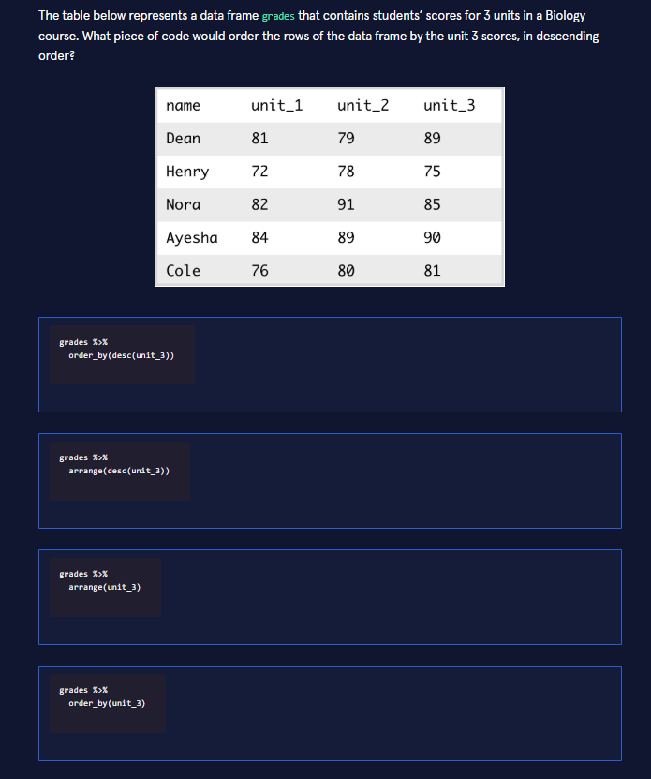
I can see you've uploaded an image with a data science question about ordering rows in a data frame using R.
Looking at this problem, you need to identify which code will order the rows by unit_3 scores in descending order.
This is using the dplyr package in R. The key elements are:
Option | Code | Correct?
1 | grades %>% order_by(desc(unit_3)) | ❌ order_by() is not a dplyr function
2 | grades %>% arrange(desc(unit_3)) | ✅ Correct!
3 | grades %>% arrange(unit_3) | ❌ This sorts ascending, not descending
4 | grades %>% order_by(unit_3) | ❌ Wrong function name

The Answer: Option 2
grades %>% arrange(desc(unit_3))
Why this works:
- arrange() is the dplyr function for ordering rows
- desc() wraps the column to sort in descending order (highest to lowest)
- unit_3 is the column being sorted
- The result would have students ordered as: Ayesha (90), Dean (89), Nora (85), Cole (81), Henry (75)
This is a common pattern when working with tidyverse data frames in R!

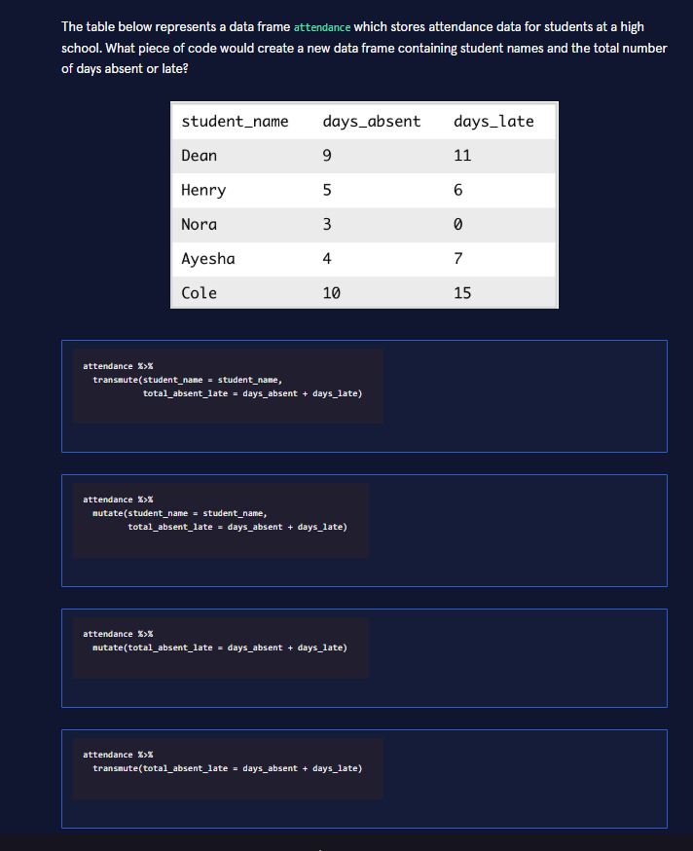
Great, another R/dplyr question! This one asks which code creates a new data frame containing only student names and the total number of days absent or late.

The Answer: Option 1
attendance %>% transmute(student_name = student_name, total_absent_late = days_absent + days_late)
Here's why each option is right or wrong:
Option | Function Used | Correct? | Reason
1 | transmute() | ✅ | Returns only the specified columns — exactly what "a new data frame containing student names and the total" implies
2 | mutate() | ❌ | Adds the new column but keeps all other columns from the original data frame — too much
3 | mutate() | ❌ | Same issue — keeps all original columns, and doesn't even select student_name
4 | transmute() | ❌ | Drops student_name — only returns the calculated column

Key Concept: transmute() vs mutate()
This is really testing whether you understand the difference between two core dplyr functions:
- mutate() — adds or modifies columns while keeping all existing columns intact
- transmute() — adds or modifies columns but only returns the ones you specify, dropping everything else
Since the question asks for a new data frame containing just student names and the total, transmute() is the correct choice. It's essentially equivalent to doing mutate() followed by select(), but in one step.

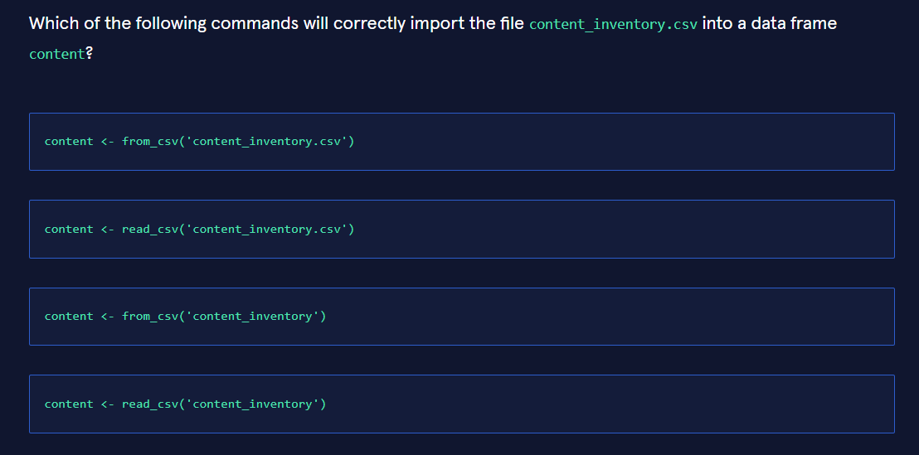
Another R question! This one tests your knowledge of how to correctly import a CSV file into a data frame.

The Answer: Option 2
content <- read_csv('content_inventory.csv')
Here's the breakdown:
Option | Function | Has .csv? | Correct?
1 | from_csv() | ✅ | ❌ — from_csv() is not a real function
2 | read_csv() | ✅ | ✅ Correct!
3 | from_csv() | ❌ | ❌ — wrong function AND missing extension
4 | read_csv() | ❌ | ❌ — missing the .csv extension

Key Concepts
read_csv() vs from_csv():
- read_csv() is a real function from the readr package (part of the tidyverse). It reads a CSV file and returns a tibble.
- from_csv() is not a standard R function — it doesn't exist in base R or popular packages like readr.
Including the file extension:
- The question specifies the file is named content_inventory.csv, so the command must reference the exact filename including the .csv extension. Without it, R won't find the file.
So the correct answer combines both the right function (read_csv()) and the complete filename ('content_inventory.csv'). 🎯
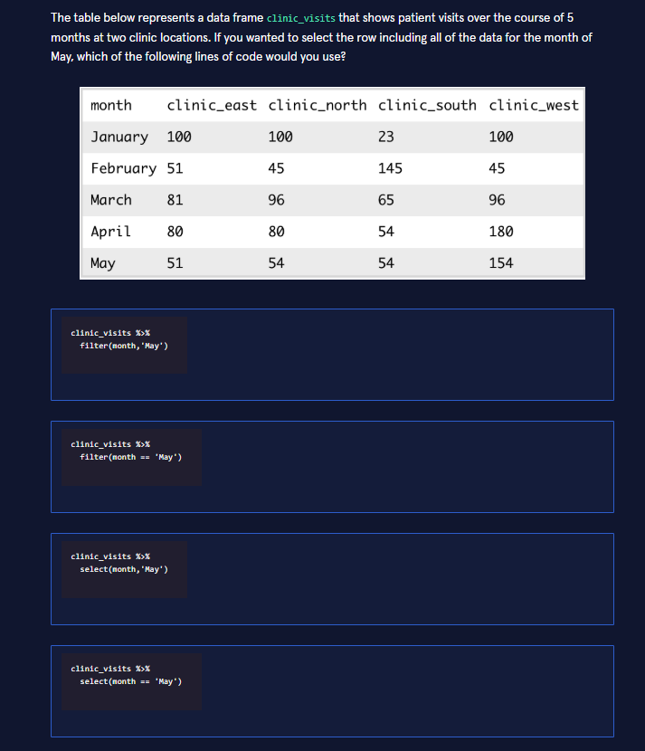

Another great dplyr question! This one tests whether you understand how to filter rows based on a condition.

The Answer: Option 2
clinic_visits %>% filter(month == 'May')
Here's why each option is right or wrong:
Option | Function Used | Syntax | Correct? | Reason
1 | filter() | filter(month, 'May') | ❌ | Wrong syntax — filter() needs a logical condition (like ==), not comma-separated values
2 | filter() | filter(month == 'May') | ✅ | Correct! Uses proper comparison operator to select rows where month equals 'May'
3 | select() | select(month, 'May') | ❌ | select() chooses columns, not rows — plus 'May' isn't a column name
4 | select() | select(month == 'May') | ❌ | select() is for columns, not row filtering — completely wrong purpose

Key Concept: filter() vs select()
This question is testing a fundamental distinction in dplyr:
Function | What it does | What it returns
filter() | Subsets rows based on conditions | All columns, only matching rows
select() | Chooses which columns to keep | All rows, only specified columns
Why == is essential:
- == is the comparison operator that creates a TRUE/FALSE condition
- filter() keeps only the rows where that condition evaluates to TRUE
- Without it, R doesn't know what comparison you want to make
So to get the May row with all 5 clinic columns intact, filter(month == 'May') is exactly right! 🎯

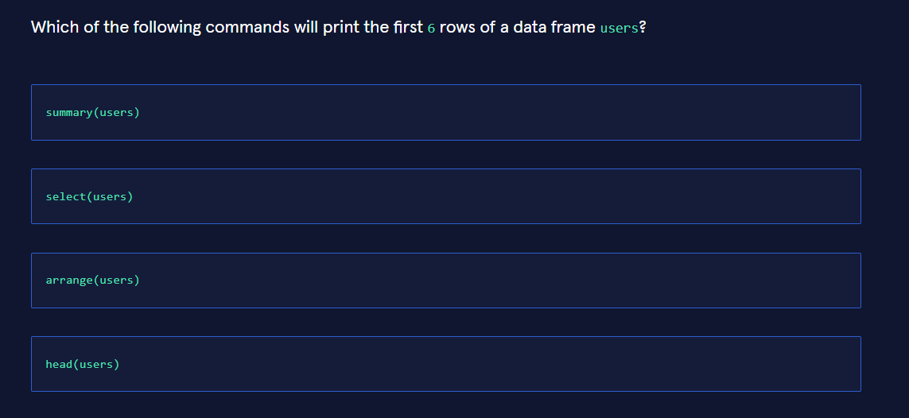

Another solid R question! This one is about the basic function for viewing the beginning of a data frame.

The Answer: Option 4
head(users)
Here's what each function actually does:
Command | Purpose | Correct? | Why Not?
summary(users) | Summary statistics (mean, median, quartiles, etc.) for each column | ❌ | Shows statistics, not raw data rows
select(users) | Choose which columns to keep from a data frame | ❌ | Requires column names, selects columns not rows
arrange(users) | Sort/ reorder rows by specified columns | ❌ | Requires columns to sort by, doesn't display rows
head(users) | Display the first 6 rows of a data frame | ✅ | Exactly what the question asks!

Key Concept: head() vs tail()
These are two essential base R functions for quick data inspection:
Function | What it does | Default behavior
head(object) | Shows the first 6 rows | head(df, n = 6)
tail(object) | Shows the last 6 rows | tail(df, n = 6)
You can customize both by specifying a different number:
- head(users, 10) — shows first 10 rows
- tail(users, 3) — shows last 3 rows
Why this matters: When exploring a new data set, head() is typically the very first thing you run to get a quick sense of the structure, variable names, and sample values. It's part of the standard "data exploration workflow" alongside str(), glimpse() (from dplyr), and summary().
So head(users) is exactly right for printing the first 6 rows! 🎯

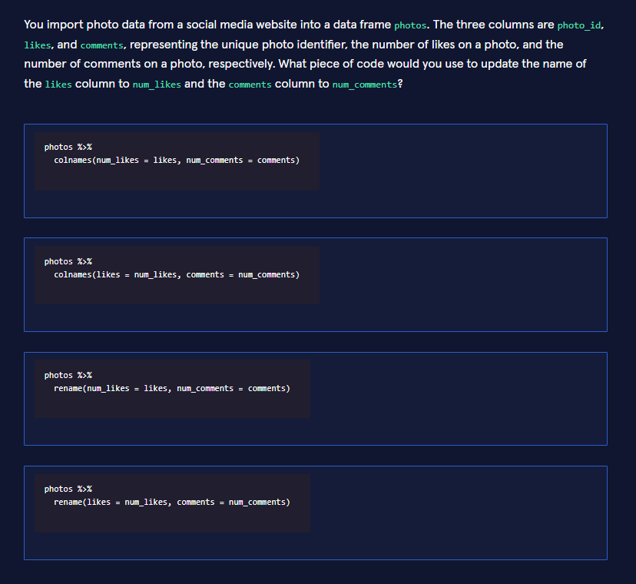

Another dplyr question — this time about renaming columns!

The Answer: Option 3
photos %>% rename(num_likes = likes, num_comments = comments)
Here's the breakdown:
Option | Function | Argument Order | Correct?
1 | colnames() | new_name = old_name | ❌ — Wrong function
2 | colnames() | old_name = new_name | ❌ — Wrong function AND reversed
3 | rename() | new_name = old_name | ✅ Correct!
4 | rename() | old_name = new_name | ❌ — Arguments are reversed

Key Concept: rename() Syntax
The rename() function from dplyr uses this pattern:
rename(new_name = old_name)
Think of it as "assigning" the old column's data to a new name — the new name goes on the left, the old name on the right, just like variable assignment in R.
Why the other options fail:
- colnames() is a base R function, not a dplyr verb. While it can rename columns, it doesn't work with the pipe (%>%) in this way — you'd need to assign a full character vector of all column names, not just the ones you want to change.
- Option 4 has the argument order backwards. rename(likes = num_likes, ...) would try to rename a column called num_likes (which doesn't exist yet) to likes — the opposite of what we want.
So Option 3 correctly renames likes → num_likes and comments → num_comments using the right function with the right syntax! 🎯
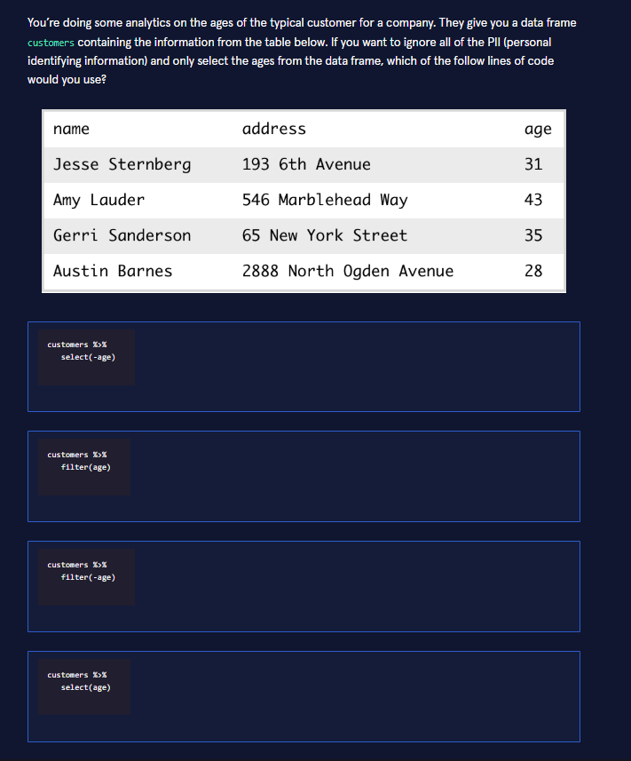
Another great dplyr question! This one tests whether you understand how to select columns while excluding others.

The Answer: Option 4
customers %>% select(age)
Here's the breakdown:
Option | Function | What it does | Correct?
1 | select(-age) | Selects all columns except age | ❌ — Gives us name and address, which are the PII we want to exclude
2 | filter(age) | Tries to filter rows based on a condition | ❌ — filter() is for rows, not columns; also needs a logical condition
3 | filter(-age) | Invalid syntax for filtering rows | ❌ — filter() is for rows; -age isn't a valid condition
4 | select(age) | Selects only the age column | ✅ Correct!

Key Concept: select() for Columns
The select() function is specifically designed to choose which columns to keep from a data frame:
- select(column_name) — keeps only that column
- select(-column_name) — keeps all columns except that one
- select(col1, col2, col3) — keeps only those specific columns
Since the question wants to "ignore all of the PII and only select the ages," we use select(age) to get just the age values while dropping name and address.
Alternative approaches:
- select(-name, -address) — also works (excludes the PII explicitly)
- select(starts_with("a")) — if you had a naming pattern
But the simplest and most direct answer is select(age)! 🎯

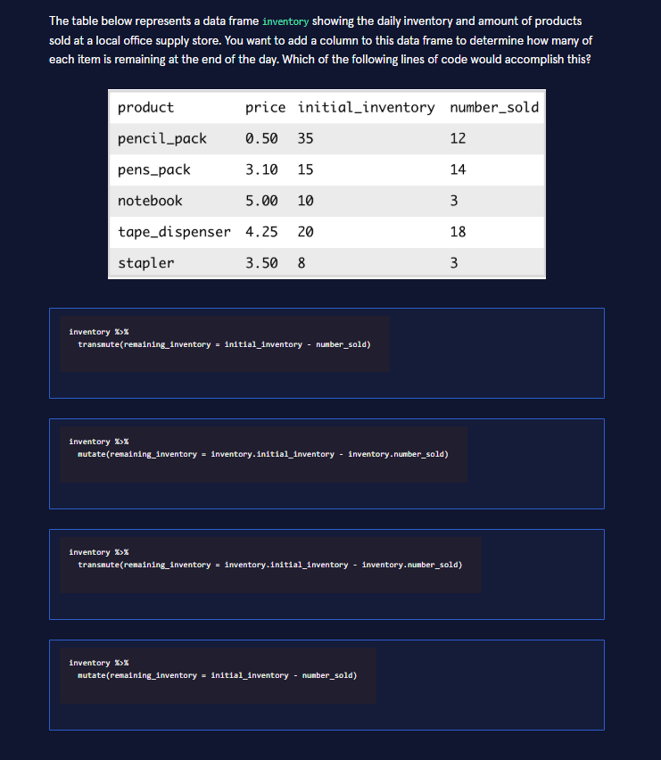
Another dplyr question! This one tests whether you understand how to add a new column to a data frame while keeping all existing columns.

The Answer: Option 4
inventory %>% mutate(remaining_inventory = initial_inventory - number_sold)
Here's the breakdown:
Option | Function | Column Reference | Correct? | Why Not?
1 | transmute() | Bare names | ❌ | Drops all other columns — we want to add a column, not replace the data frame
2 | mutate() | inventory.initial_inventory | ❌ | Uses dot notation (inventory.) — that's not how you reference columns inside dplyr verbs; this is Python pandas syntax, not R
3 | transmute() | inventory. prefix | ❌ | Same issues as Option 1 and Option 2 combined
4 | mutate() | Bare names | ✅ | Correct! Adds the new column while keeping all originals

Key Concepts
mutate() vs transmute() — again!
- mutate() — adds a new column and keeps all existing columns ✅ (what we want here)
- transmute() — adds a new column but drops everything else ❌
The question says "add a column to this data frame," which means the existing columns (product, price, initial_inventory, number_sold) should all still be there alongside the new remaining_inventory column. That's mutate().
Column references in dplyr: Inside mutate() (and other dplyr verbs), you refer to columns by their bare names — no $, no ., no quotes. The pipe (%>%) passes the data frame into the function, and dplyr automatically makes the columns available in the evaluation environment.
So initial_inventory - number_sold is the correct way to reference those columns! 🎯

Explore the 1985 Cars Dataset
Have you ever wanted to have a collection of something? It could be trading cards, board games, art pieces, or whatever you want them to be. In this project, we’ll suppose you collect something with a lot of data - cars!
Your car collection is almost complete - it’s just missing one thing. You think about it for a while, then it comes to you - you don’t have a car from 1985! But there are so many cars from 1985 available for you to collect! How will you know which 1985 car you will buy for your collection?
Luckily for you, we have a dataset that stores precisely that information. This dataset comes from the UCI Machine Learning Repository and is linked here. This dataset has been adapted so that the variable names are along the first rows.
As you’ll notice in this project, though, this dataset isn’t ready for analysis yet. You will have to make some changes along the way to clean and tidy up the dataset. Do that, and you’ll have the ability to perform a great analysis!
Click the “Start” button below to get started!

Tasks
0/15 complete
Mark the tasks as complete by checking them off

Loading and Inspecting the Data
- 1.
- What good is an analysis if we don’t even have the tools to perform the said analysis? Some of the tools you will need for this analysis are the readr and dplyr tidyverse packages. Load the libraries at the top of the notebook.Rmd file so you can access the functions you will need later on.
- 2.
- The last tool we need is the data itself! The file cars85.csv stores the data that comes from the UCI Machine Learning Repository. Load the file into a dataframe called cars to get started.
- 3.
- It’s always a good idea to inspect the data you load into R. It helps you to know what you are working with. Inspect cars with head() and summary().
- What kind of information do you have? What can you do with this information?
- Each row in this dataframe is a single car, and each column stores some characteristic about that car. You want to get the best value for your collection, so you want to analyze as much as you can before buying. Doing so will help you make your choice easier!

Clean the Data
- 4.
- After inspecting the dataframe, you notice something odd about the normalized_losses column. This column has a lot of entries that are question marks (?). This variable is not worth looking at since we don’t have all the cars’ expected losses.
- Let’s remove this column from the dataset. Select all columns from cars but normalized_losses. Save your new dataframe to cars.
- 5.
- Print the column names of cars. Are they clear and descriptive?
- 6.
- You know, symboling doesn’t say anything to you at first glance. According to the UCI webpage, the symboling variable represents the car’s risk factor. That variable name doesn’t seem to go with the description. You should simplify this variable name to have it make more sense.
- Update that column name in cars as follows:
  - symboling -> risk_factor
- Print the column names of cars to confirm the names of the columns have changed.

Add a Column
- 7.
- Your car collection means a lot to you. You want each car to be of value to you. What better way to do that than to buy a car with a lot of miles-per-gallon on the highways? To determine this, first, suppose only cars exceeding 30 mpg on the highways interest you. You seek to measure how different each car’s highway mpg is from your 30 mpg threshold. Create a variable called mpg_threshold with the value 30.
- 8.
- Add a new column to cars called mpg_diff_from_threshold. This will measure how far each car’s highway mpg is from 30 mpg. View the updated cars dataframe.

Filter and Arrange Rows
- 9.
- You’ll add a car to your collection only if it gets more than 30 miles per gallon on the highways. Filter the rows of cars to find all the cars where mpg_diff_from_threshold is greater than 0. Save this new dataframe to mpg_exceeds_threshold and view it.
- 10.
- Which cars have the highest miles per gallon on the highways? To find this, arrange the rows of mpg_exceeds_threshold by mpg_diff_from_threshold descending. Save this new dataframe as mpg_exceeds_threshold.
- 11.
- Now suppose you want your next car to have a large engine. Order the rows of cars by engine_size descending. Save the new data frame to ordered_by_engine_size. View ordered_by_engine_size.

Specifying the Make of the Car
- 12
- There’s a lot of makes of cars to choose from, but you may prefer one over the others. Which make do you prefer the most? Create a variable called chosen_make that contains the make you want to check. The hint below provides the list of makes to choose from.
- 13.
- Filter cars to only include rows where the make column is equal to chosen_make. Save the new dataframe to chosen_make_details.
- 14.
- Order the rows of chosen_make_details by engine_size descending and save the new dataframe to chosen_make_details. View chosen_make_details.
- How large are the engines in each of the cars from that make that you chose? You can change the make stored in chosen_make to check out the engine sizes for other makes.
- 15.
- The process of buying a new car can cause a lot of stress - you don’t want to buy a car you won’t like! You’ve now seen how performing an analysis can ease some of the stress of making the decision of which car to buy. You also get to add a nice new car to your collection! Great work!
---title: "1985 Cars"output: html-notebook---# Task 1```{r message=FALSE, warning=FALSE, error=TRUE}# load libraries
```
# Task 2
```{r error=TRUE}
# load data

```
# Task 3
```{r error=TRUE}
# inspect data

```
# Task 4
```{r error=TRUE}
# select columns

```
# Task 5
```{r error=TRUE}
# view columns

```
# Task 6
```{r error=TRUE}
# rename column

```
# Task 7
```{r error=TRUE}
# define threshold

```
# Task 8
```{r error=TRUE}
# add column

```
# Task 9
```{r error=TRUE}
# filter rows

```
# Task 10
```{r error=TRUE}
# arrange rows

```
# Task 11
```{r error=TRUE}
# order rows by engine size

```
# Task 12
```{r error=TRUE}
# choose make

```
# Task 13
```{r error=TRUE}
# filter rows by make

```
# Task 14
```{r error=TRUE}
# order filtered rows by engine size

```

Here's the completed project in JSON format, with all 15 tasks filled in:
{ "project_title": "Explore the 1985 Cars Dataset", "source": "UCI Machine Learning Repository", "file_type": "R Notebook (.Rmd)", "tasks": [ { "task": 1, "section": "Loading and Inspecting the Data", "instruction": "Load the readr and dplyr tidyverse packages.", "code": "library(readr)\nlibrary(dplyr)" }, { "task": 2, "section": "Loading and Inspecting the Data", "instruction": "Load the file cars85.csv into a dataframe called cars.", "code": "cars <- read_csv('cars85.csv')" }, { "task": 3, "section": "Loading and Inspecting the Data", "instruction": "Inspect cars with head() and summary().", "code": "head(cars)\nsummary(cars)" }, { "task": 4, "section": "Clean the Data", "instruction": "Remove the normalized_losses column from cars. Save to cars.", "code": "cars <- cars %>%\n select(-normalized_losses)" }, { "task": 5, "section": "Clean the Data", "instruction": "Print the column names of cars.", "code": "colnames(cars)" }, { "task": 6, "section": "Clean the Data", "instruction": "Rename symboling to risk_factor. Print column names to confirm.", "code": "cars <- cars %>%\n rename(risk_factor = symboling)\ncolnames(cars)" }, { "task": 7, "section": "Add a Column", "instruction": "Create a variable called mpg_threshold with the value 30.", "code": "mpg_threshold <- 30" }, { "task": 8, "section": "Add a Column", "instruction": "Add a new column mpg_diff_from_threshold measuring how far each car's highway mpg is from 30. View the updated dataframe.", "code": "cars <- cars %>%\n mutate(mpg_diff_from_threshold = highway_mpg - mpg_threshold)\nhead(cars)" }, { "task": 9, "section": "Filter and Arrange Rows", "instruction": "Filter rows where mpg_diff_from_threshold is greater than 0. Save to mpg_exceeds_threshold and view it.", "code": "mpg_exceeds_threshold <- cars %>%\n filter(mpg_diff_from_threshold > 0)\nmpg_exceeds_threshold" }, { "task": 10, "section": "Filter and Arrange Rows", "instruction": "Arrange mpg_exceeds_threshold by mpg_diff_from_threshold descending. Save as mpg_exceeds_threshold.", "code": "mpg_exceeds_threshold <- mpg_exceeds_threshold %>%\n arrange(desc(mpg_diff_from_threshold))" }, { "task": 11, "section": "Filter and Arrange Rows", "instruction": "Order the rows of cars by engine_size descending. Save to ordered_by_engine_size. View it.", "code": "ordered_by_engine_size <- cars %>%\n arrange(desc(engine_size))\nordered_by_engine_size" }, { "task": 12, "section": "Specifying the Make of the Car", "instruction": "Create a variable called chosen_make that contains the make you want to check.", "code": "chosen_make <- 'toyota'" }, { "task": 13, "section": "Specifying the Make of the Car", "instruction": "Filter cars to only include rows where make equals chosen_make. Save to chosen_make_details.", "code": "chosen_make_details <- cars %>%\n filter(make == chosen_make)" }, { "task": 14, "section": "Specifying the Make of the Car", "instruction": "Order chosen_make_details by engine_size descending and save. View it.", "code": "chosen_make_details <- chosen_make_details %>%\n arrange(desc(engine_size))\nchosen_make_details" }, { "task": 15, "section": "Conclusion", "instruction": "Reflect on the analysis process and how it eases the stress of buying a car.", "code": "# Analysis complete!\n# We cleaned the data, filtered for fuel-efficient cars,\n# sorted by engine size, and narrowed down by make.\n# This data-driven approach helps make an informed decision\n# for adding a 1985 car to our collection!" } ], "rmd_output": "---\ntitle: \"1985 Cars\"\noutput: html-notebook\n---\n\n# Task 1\n```{r message=FALSE, warning=FALSE, error=TRUE}\n# load libraries\nlibrary(readr)\nlibrary(dplyr)\n```\n# Task 2\n```{r error=TRUE}\n# load data\ncars <- read_csv('cars85.csv')\n```\n# Task 3\n```{r error=TRUE}\n# inspect data\nhead(cars)\nsummary(cars)\n```\n# Task 4\n```{r error=TRUE}\n# select columns\ncars <- cars %>%\n select(-normalized_losses)\n```\n# Task 5\n```{r error=TRUE}\n# view columns\ncolnames(cars)\n```\n# Task 6\n```{r error=TRUE}\n# rename column\ncars <- cars %>%\n rename(risk_factor = symboling)\ncolnames(cars)\n```\n# Task 7\n```{r error=TRUE}\n# define threshold\nmpg_threshold <- 30\n```\n# Task 8\n```{r error=TRUE}\n# add column\ncars <- cars %>%\n mutate(mpg_diff_from_threshold = highway_mpg - mpg_threshold)\nhead(cars)\n```\n# Task 9\n```{r error=TRUE}\n# filter rows\nmpg_exceeds_threshold <- cars %>%\n filter(mpg_diff_from_threshold > 0)\nmpg_exceeds_threshold\n```\n# Task 10\n```{r error=TRUE}\n# arrange rows\nmpg_exceeds_threshold <- mpg_exceeds_threshold %>%\n arrange(desc(mpg_diff_from_threshold))\n```\n# Task 11\n```{r error=TRUE}\n# order rows by engine size\nordered_by_engine_size <- cars %>%\n arrange(desc(engine_size))\nordered_by_engine_size\n```\n# Task 12\n```{r error=TRUE}\n# choose make\nchosen_make <- 'toyota'\n```\n# Task 13\n```{r error=TRUE}\n# filter rows by make\nchosen_make_details <- cars %>%\n filter(make == chosen_make)\n```\n# Task 14\n```{r error=TRUE}\n# order filtered rows by engine size\nchosen_make_details <- chosen_make_details %>%\n arrange(desc(engine_size))\nchosen_make_details\n```"}
Here's a summary of what each task accomplishes and the key dplyr functions used:
Tasks | Section | Key Functions
1–3 | Loading & Inspecting | library(), read_csv(), head(), summary()
4–6 | Clean the Data | select(-col), colnames(), rename(new = old)
7–8 | Add a Column | Variable assignment, mutate(new = col - threshold)
9–11 | Filter & Arrange | filter(condition), arrange(desc(col))
12–14 | Specifying the Make | Variable assignment, filter(col == var), arrange()
The JSON includes both a structured tasks array (each task with its instruction and code) and a ready-to-use rmd_output string containing the complete .Rmd file content. You can copy the rmd_output value directly into a new R Notebook file.
A few notes:
- For Task 12, I used 'toyota' as the example make — you can swap this for any make in the dataset (e.g., 'honda', 'bmw', 'mercedes-benz')
- The column name highway_mpg assumes the dataset uses that exact name — if it differs (e.g., highway-mpg), adjust accordingly
- All code uses the pipe (%>%) operator and tidyverse conventions consistent with the earlier quiz questions you shared

